Dear {%FName%},  
  
Our district has been presenting Rotary Leadership Institute (RLI) sessions for Rotarians since 2014 when we first introduced the program to the district. Since that time, hundreds of Rotarians have participated in the program. While the Covid pandemic cramped our style, we were able to run a full program of Parts I, II and III via Zoom. Now that life is becoming more normal, we are back to in-person, facilitated RLI sessions. We recently completed a session at Laurel Oaks with both Part I and Part III. If you attended Part i in November, now is the time to sign up for Part II.  
  
The next RLI program will be held on January 28, 2023 from 8 AM to 3:45 PM at the Laurel Oaks Career Center in Wilmington, Ohio. These sessions are open for all Rotarians, not just those entering leadership roles in their club or our district. Each facilitated session is designed to assist our members to learn about the great organization that we call Rotary. I'd like to invite you to register and attend in January. The cost is low, $50 pays for breakfast, lunch and a full day of facilitated learning with fellow Rotarians. Most clubs are happy to reimburse their members who attend. RLI is taken in sequence, Part I, Part II and Part II. Please use this link to register today:  
 [**Register NOW**](https://www.dacdb.com/login.cfm?EventID=77636502&UserID=%7b%25UserID%25%7d) for **RLI Parts I, II and III, In-Person - District 6670**  
  
Please feel free to contact me with any questions you may have and I look forward to meeting you on January 28.  
Light Up Rotary!  
  
Eric  
  
Eric Marcus  
RLI Coordinator  
District 6670  
  
3476 Riva Ct.  
Beavercreek, OH 45430  
  
Cell: 937-602-0367  
  
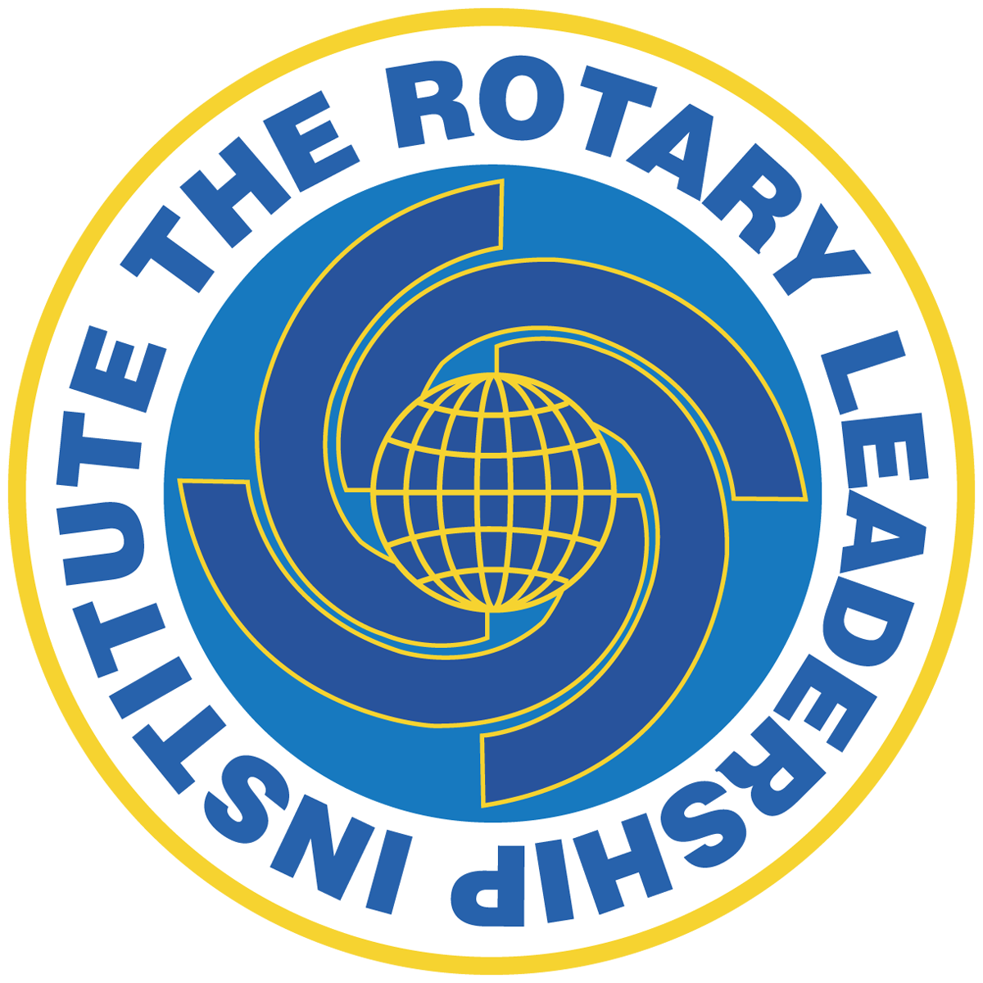

Dear {%FName%},  
  
Our district has been presenting Rotary Leadership Instititure (RLI) sessions for Rotarians since 2014 when we first introduced the program to the district. Since that time, hundreds of Rotarians have participated in the program. While the Covid pandemic cramped our style, we were able to run a full program of Parts I, II and III via Zoom. Now that life is becoming more normal, we are back to in-person, facilitated RLI sessions.  
  
The next RLI program will be held on November 5, 2022 from 8 AM to 3:45 PM at the Laural Oaks Career Center in Wilmington, Ohio. These sessions are open for all Rotarians, not just those entering leadership roles in their club or our district. Each facilitated session is designed to assist our members to learn about the great organization that we call Rotary. I'd like to invite you to register and attend in November. The cost is low, $50 pays for breakfast, lunch and a full day of facilitated learning with fellow Rotarians. Most clubs are happy to reimburse their members who attend. RLI is taken in sequence, Part I, Part II and Part II. Please use this link to register today:  
  [**Register NOW**](https://www.dacdb.com/login.cfm?EventID=77585918&UserID=%7b%25UserID%25%7d) for **RLI Parts I, II and III, In-Person - District 6670**  
  
Please feel free to contact me with any questions you may have and I look forward to meeting you on November 5.  
  
Light Up Rotary!  
  
Eric  
  
Eric Marcus  
RLI Coordinator  
District 6670  
  
3476 Riva Ct.  
Beavercreek, OH 45430  
  
Cell: 937-602-0367  
